^{Profile No.} ^{Date Received} 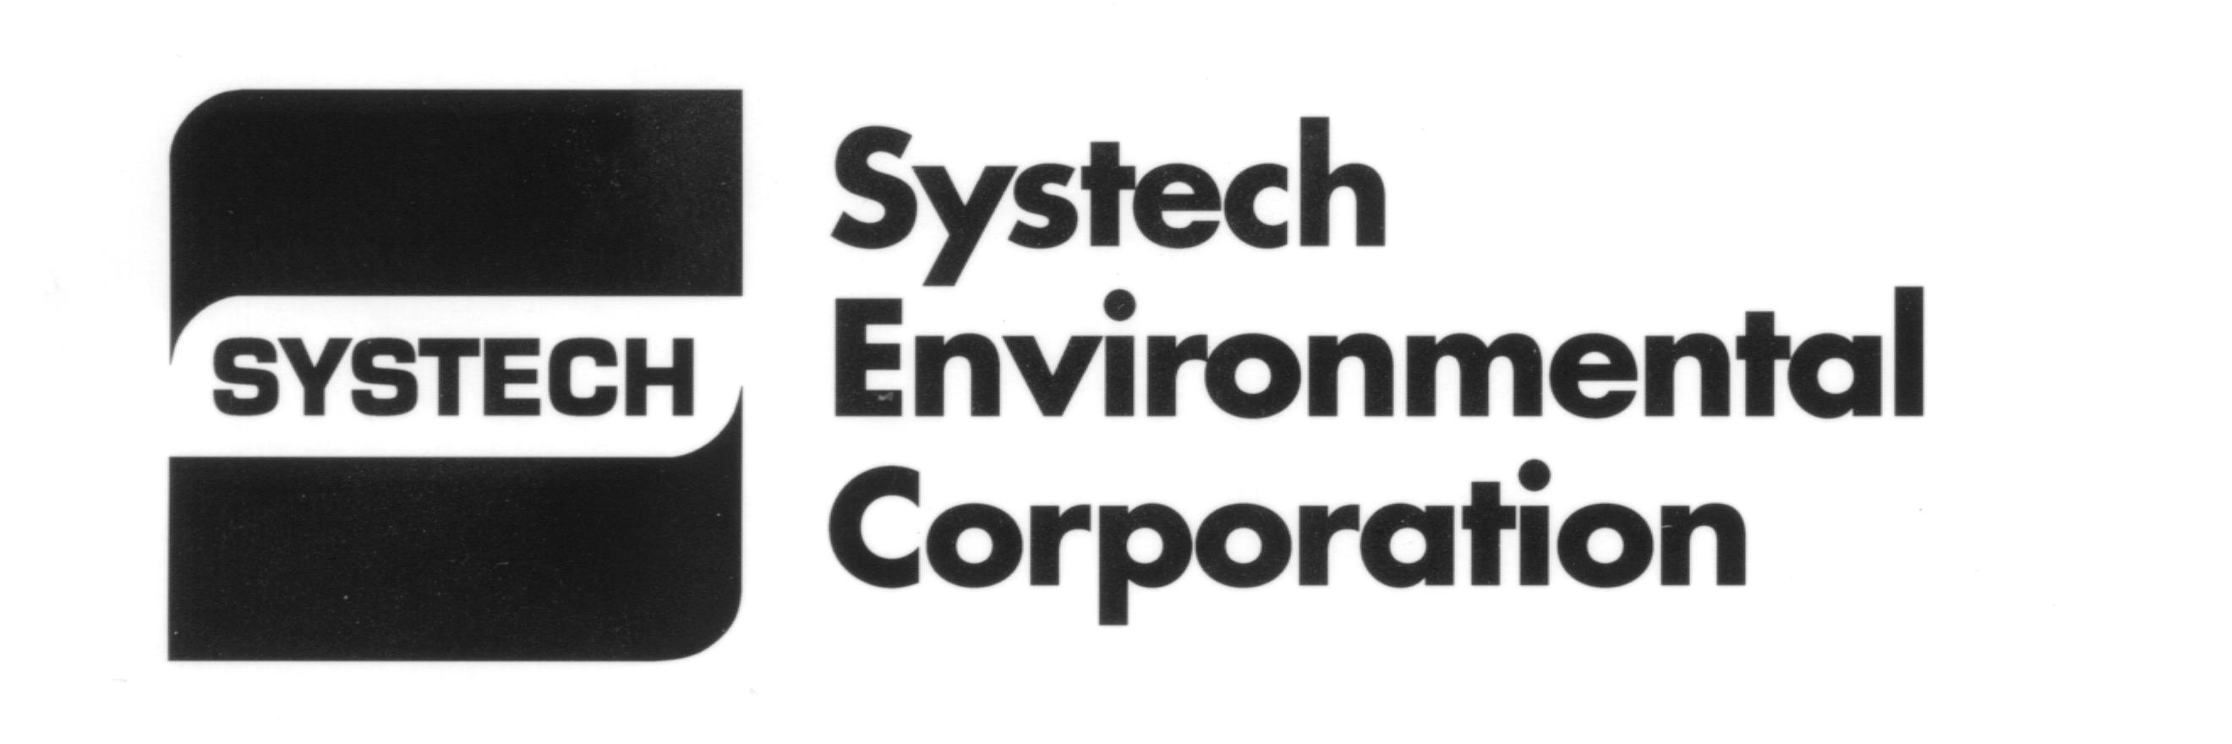

Form 1 – Alternate Raw Material & Fuel Qualification - Information
A representative sample needs to accompany this form

SALES REPRESENTATIVE Ray Nobles Phone 843-532-0483 Facility Harleyville

A. CONTACT INFORMATION
GENERATOR Technical Contact
Phone FAX Email
Address
City State Zip

MARKETER (if different than Generator)
Company Name Business Contact
Phone FAX Email
Address
City State Zip

B. BYPRODUCT INFORMATION
Byproduct name
Process generating byproduct
Is the material generated from a superfund site? no yes
Is the byproduct liquid solid sludge other % free liquid
If this byproduct is a liquid or sludge what is the moisture content? %
List any known health & safety precautions
Exposure limits and carcinogens?
Attach the following if available: TCLP Metals TCLP Organics Other analytical
Is a Material Safety Data Sheet (MSDS) available for the waste? Y N (Please attach)
If no, is an MSDS available for the finished product or product constituents? Y N (Please attach)

Define composition by listing the primary constituents and/or material types. (Must total to 100%.)
Material % Material %

C. SHIPMENT INFORMATION
Quantity of byproduct available per month gal. lb. yd³ or ton
Method of shipment: Delivery frequency
Anticipated handling problems (e.g., odor, dusty, sticky, large chunks, foreign matter):
Emergency and first aid procedures?

Please send this profile with a one (1) quart representative sample, photos, any analyses or other information to:

Systech Environmental Corporation
467 Judge Street, P.O. Box 66, Harleyville, SC 29448

D. NON-HAZARDOUS WASTE CERTIFICATION
I hereby certify that the byproduct identified in this qualification does not exhibit the characteristic of a hazardous waste
or is not a listed hazardous waste as defined in 40 CFR 261.

The undersigned states that they are a duly authorized representative of the generator and that the information and statements included on this questionnaire are true and correct to the best of their knowledge.

Print name Title

Signature Date

Basis for certification (knowledge, analysis, etc.)

