Profile No. ____________ Date Received _______________ 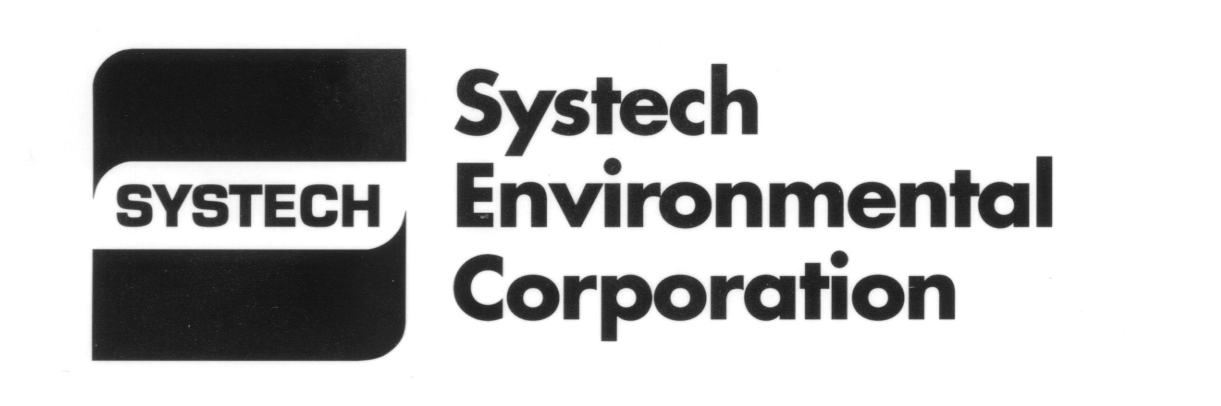

Form 1 – Alternate Raw Material & Fuel Qualification - Information

A representative sample accompanies this form

SALES REPRESENTATIVE ____________________________Phone (_____) _______________________________
FACILITY LOCATION_____________________________________________________________________________

A. CONTACT INFORMATION
GENERATOR ___________________________________ Technical Contact _________________________________
Phone ( )___________________ FAX ( ) _________________ Email ________________________________
Address ________________________________________________________________________________________
City _________________________________________________ State ________________ Zip _________________

MARKETER (if different than Generator)
Company Name ____________________________________ Business Contact _______________________________
Phone ( )___________________ FAX ( ) _________________ Email ________________________________
Address ________________________________________________________________________________________
City _________________________________________________ State ________________ Zip _________________

B. BYPRODUCT INFORMATION
Byproduct name __________________________________________________________________________________
Process generating byproduct _______________________________________________________________________
Is the material generated from a superfund site? ____ no ____ yes
Is the byproduct ___liquid ___solid ___ sludge ____ other % free liquid ____________
If this byproduct is a liquid or sludge what is the moisture content? ___________%
List any known health & safety precautions ____________________________________________________________
Exposure limits and carcinogens? ___________________________________________________________________
Attach the following if available: TCLP Metals ______ TCLP Organics ______ Other analytical ___________________
Is a Material Safety Data Sheet (MSDS) available for the waste? Y____ N____ (Please attach)
If no, is an MSDS available for the finished product or product constituents? Y____ N____ (Please attach)

Define composition by listing the primary constituents and/or material types. (Must total to 100%.)
Material % Material %
_________________________________ ___________________________________
_________________________________ ___________________________________
_________________________________ ___________________________________

This form must be resubmitted any time the waste stream coming to the facility changes.

C. SHIPMENT INFORMATION
Quantity of byproduct available per month ______________ gal. _______________lb. ________yd³ ________ton
Method of shipment: _____________________________ Delivery frequency_________________________________
Anticipated handling problems (e.g., odor, dusty, sticky, large chunks, foreign matter): __________________________
Emergency and first aid procedures? _________________________________________________________________

Please send this profile with a one (1) quart representative sample, photos, any analyses or other information to:

Systech Environmental Corporation
3085 Woodman Drive, Dayton, OH 45420

D. NON-HAZARDOUS WASTE CERTIFICATION
I hereby certify that the byproduct identified in this qualification does not exhibit the characteristic of a hazardous waste or is not a listed hazardous waste as defined in 40 CFR 261.

The undersigned states that they are a duly authorized representative of the generator and that the information and statements included on this questionnaire are true and correct to the best of their knowledge.

Print name __________________________________________ Title _______________________________________

Signature ___________________________________________Date _______________________________________

Basis for certification ______________________________________________________________________________
Version 9 – US Dayton October 2013

